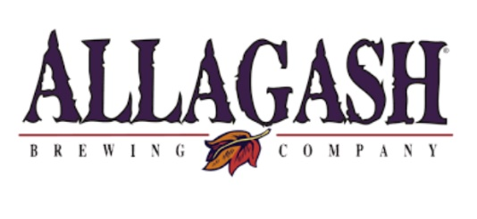****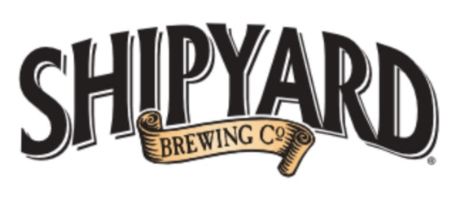

**53rd Annual Pilot Regatta – June 16th**

Dear Skippers and Crew:

Please join the Portland Yacht Club for the **53rd Annual Pilot Regatta** on Saturday, June 16th!

**New This Year:**

We’ll be starting a little later this year to catch the ocean breeze for racing, cruising, laser and laser radial classes. First warning gun is at 1300.

Join the membership for a great party at the end of the day. Awards! Dancing to the Desperate Avikadoz!! Terrific dinner options for all!!!!

We have two dinner options available:

* Chef Stacy’s amazing buffet of: Jamaican style chicken, baby back ribs, mahi mahi, corn on the cob, salads and dessert or
* Build-a-burger and chips

Download the Notice of Race and Register at: [Regatta Management Solutions - Pilot Regatta](https://www.regattaman.com/def_event_page.php?race_id=169&cancel_dest=calendar.php)